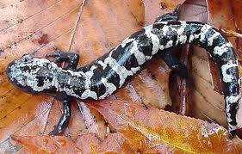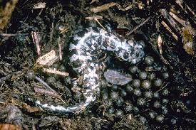

Hi, I’m Molly/Mike, a marbled salamander. I’m actually one of North Carolina’s state amphibians. I live underground or under logs for most of the year but in the fall I move to dried-up small ponds to lay eggs on the dry ground. After the fall rains come I leave my eggs (which hatch into salamander larvae with gills) and head back to my hideouts. I lay about 100 eggs, which are the size of BBs. Once my larvae hatch they grow all winter and then I leave the pond for dry ground as a metamorph. I have to get out fast so I don’t become someone else’s food source. I breathe through gills when I’m a larva but through lungs when I’m an adult. My skin is very permeable though and so I can tell you a lot about water quality and air quality. If you want to keep me around be sure to leave some ponds without fish (fish love to eat my eggs) and don’t let your fertilizers and herbicides and insecticides run off into my pool.

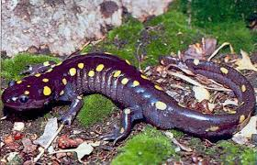

Hi, I’m Sally/Sam, a spotted salamander. I’m one of North Carolina’s largest (and I dare say prettiest) amphibians. I live underground or under logs for most of the year but in the spring I move to small ponds to court and then lay eggs. I lay my eggs in a large clump that can be as big as a softball. My eggs hatch into salamander larvae with gills while I head back to my hideout after about a month in the pond. Once my larvae hatch they grow all spring and summer and then I leave the pond for dry ground as a metamorph with a few small yellow dots. I breathe through gills when I’m a larva but through lungs when I’m an adult. My skin is very permeable though and so I can tell you a lot about water quality and air quality. If you want to keep me around be sure to leave some ponds without fish (fish love to eat my eggs) and don’t let your fertilizers and herbicides and insecticides run off into my pool.

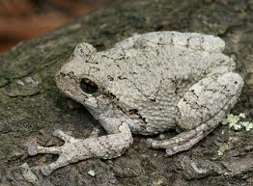

Hi, I’m Caitlin/Cory, a Copes Grey Treefrog. I’m one of North Carolina’s loudest amphibians, well, that is…if I’m Cory (Caitlin can’t call – only male frogs call). In the calling season you can tell male frogs from females because males have black throats. I spend a lot of time in trees but like most frogs and toads, I move to small ponds to court and lay eggs. Once my larvae, called tadpoles, hatch, they grow all spring and summer and and then I metamorphose and leave the pond as a frog or froglet. I breathe through gills when I’m a larva but through lungs when I’m an adult. My skin is very permeable though and so I can tell you a lot about water quality and air quality. If you want to keep me around be sure to leave some ponds without fish (fish love to eat my eggs) and don’t let your fertilizers and herbicides and insecticides run off into my pool.

Hi, I’m Pam/Paul, a Painted Turtle. I am without a doubt North Carolina’s most beautiful semi-aquatic turtle (semi-aquatic means I spend most of my time in the water but I actually lay my eggs on land – but then again, I am a reptile). I eat aquatic plants, aquatic animals and dead things in the water. Young painted turtles can actually freeze and survive. So, I’m very adaptable. I love to bask so look for me on a log on nice, warm, sunny days.

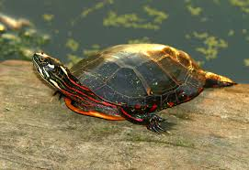

Hi, I’m Molly/Mike a Mole Kingsnake. You know why they call us kingsnakes don’t you…well, we eat lots of things (lizards and rodents), including venomous snakes – so we’re the king of snakes! We look a lot like corn snakes and people often mistake us for cornsnakes. While I spend a lot of my time underground I’m infrequently above ground for day and evening scoots and slithers. Many people kill me because they think I’m a copperhead (not that you should kill copperheads either) but hey, I’m harmless.

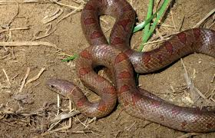

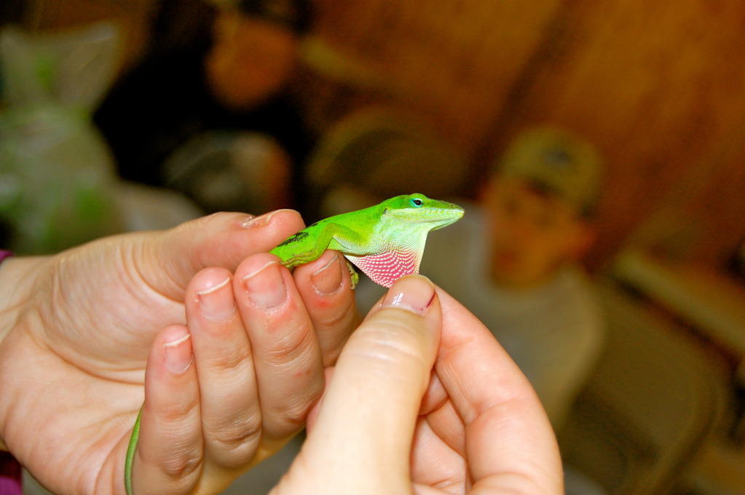

Anole

Hi, I’m Ann/Adam a lizard called a Carolina Anole. I eat insects and other arthropods and if I’m captured by a predator, I can release my tail. My tail wiggles and jumps and distracts the predator so I can get away. Cats are my enemies so keep your cats inside your house. I am usually green but if I get distressed I turn brown. I’m having a hard time right now because brown anoles are moving up from Florida, invading my space and pushing me out of my preferred niches in bushes and trees. I don’t know how I’ll fare if brown anoles get to North Carolina.

