**The HERP Project, Herpetology Education in Rural Places and Spaces**

**In Awe of Nature: Peering at Pond Life**

|  |  |
| --- | --- |
|  |  |
|  |  |

Written by Catherine E. Matthews, Ann Berry Somers, and Lacey Huffling



The Herp Project is supported by the National Science Foundation, Grant No. DRL-1114558. Any opinions, findings, and conclusions or recommendations expressed in this manuscript are those of the authors and do not necessarily reflect the views of the National Science Foundation.

**Peering at Pond Life**

Before starting a project similar to the one described in this curriculum, contact your state wildlife resources commission or state division of fish and gameabout regulations related to salamanders, frogs, and snakes (all of which may be caught in minnow traps or aquatic dip nets) to see what kinds of permits you need to handle the animals that live in or near ephemeral pools. Terms used interchangeably in this document are: temporary ponds, temporary pools, temporary puddles, seasonal wetlands, ephemeral pools, and vernal pools.

**I. Project Description**

This curriculum project focuses on the studies of amphibians and reptiles that use temporary puddles or seasonal wetlands called **ephemeral pools**. This curriculum describes studies we conducted with our high school participants and teachers as a part of The HERP Project’s (Herpetology Education in Rural Places and Spaces) Herpetological Research Experience (HRE). This curriculum provides ideas for conducting educational programs and scientific investigations on temporary ponds. As a part of this curriculum, we provide information about ephemeral pools and describe how we conducted descriptive studies of various ephemeral pools in the North Carolina Piedmont. We describe our sampling methods and techniques and our data collection and reporting procedures. This curriculum describes how leaders of formal and informal outdoor learning experiences can teach about organisms that live in temporary (ephemeral) pools using minnow traps and aquatic dip nets to sample the aquatic environment. Participants learn about ephemeral pool inhabitants and populations of organisms found in them. They engage in scientific procedures and ways of thinking associated with a biological inventory.

We begin our ephemeral pool studies with a very open-ended inquiry question:

* What organisms (salamanders, frogs, and macroinvertebrates) are found in this body of water?
* What parts of the pool do each of these organisms prefer?
* Who eats whom?
* How do the various species (for example, frogs and salamanders) partition the habitat so that each gets what they need?
* Who is active during the day (diurnal) and who is active at night (nocturnal)?

Next, we ask a procedural question: “How can we find out what kinds of animals are in this ephemeral pool?” We introduce participants to minnow traps and aquatic dip nets (see Materials). We talk to students about sampling and estimating our work area. We also compute **capture efficiency**, called capture per unit effort (CPUE), which is an indirect measure of the abundance of the species of interest. For this measurement, we need to know how much time we as a group spend sampling (effort). For example, if there are three people dip-netting in the pool for one hour, that equals three hours of effort. If 12 marbled salamander larvae are captured during that time, then we divide the total number of salamanders (12) by the effort (three hours); this means the CPUE for that pool is four salamanders per hour.

We start our study with unbaited minnow traps, which capture salamanders, frogs, and snakes. Unbaited minnow traps are set in what appear to be ephemeral pools. Within 24 hours, traps are checked, organisms are removed, data are collected, and the organisms are released at the point of capture.

In addition to collecting data on biological organisms (**biotic data**), we collect data on **abiotic factors** at ephemeral pools. We take pH, air and water temperatures, and measure the circumference and maximum depth of the pools. We set minnow traps and check these within 24 hours. We typically catch tadpoles, salamander larvae, adult frogs, adult salamanders, and aquatic **macroinvertebrates** in our minnow traps. We occasionally catch water snakes.

Our ephemeral pools project focuses on gathering baseline data on **obligate** (organisms that must use ephemeral pools for breeding) and **facultative** (organisms that are not “obligated” to use ephemeral pools but use them for convenience) organisms that use each pool. Obligate species must reproduce in a fishless environment which temporary pools provide. We record times when these organisms are active and note the life stages observed in each pool. Ephemeral pools provide critical breeding and nesting grounds for many different amphibians, which are excellent bio-indicators of environmental conditions such as water quality.

We also conduct visual searches for adult amphibians under artificial coverboards (sheets of wood or tin) as well as under logs and rocks. The best times to search for adult salamanders that are obligate species in ephemeral pools are just before or just after their breeding seasons. For example, looking under logs in dry ephemeral pools in mid- to late fall often yields male and female marbled salamanders or female marbled salamanders with their bodies wrapped around many, many eggs, waiting for fall rains to fill the pool. Looking under logs and rocks that are near ephemeral pools in the early spring and late spring can yield adult spotted salamanders on their way to and from the ephemeral pools, their breeding grounds. Take care to replace logs or coverboards gently so the animals won’t be harmed.

Ephemeral wetlands are abundant in rural areas of North Carolina’s Piedmont in the spring and in the fall. Depressions in the ground with clay bottoms hold rainwater and sometimes fill with overflow from nearby streams. Typically, these pools are shallow and are subjected to high levels of evaporation and transpiration from surrounding woody vegetation. One of our ephemeral pools dries up nearly every summer. Another pool has never dried up completely but certainly becomes smaller as the summer days heat up. As pools dry out, animal inhabitants must find another place to live. If pools dry out too quickly animal losses may be greater since larval metamorphosis might not be able to keep pace with the rate of evaporation.

Ephemeral pool wetland ecosystems support many amphibian species and are the sole breeding grounds for some species, such as certain species of *Ambystoma* (mole) salamanders. There are at least 39 species of amphibians in North Carolina that either use ephemeral pools exclusively or are found using them at some point during their life cycles. Ephemeral pools are important to many other species too including reptiles, birds, and insects. Ephemeral pools vary in size and depth, and it is critical that they dot the landscape to provide habitat for amphibians, which generally rely on aquatic habitats to raise young. Some wetlands may be deep, some shallow. Some stay wet most of the year or even all year; others dry out after several days or even several hours. Some wetlands are used more frequently in wetter years than drier years.

According to Best and Welch (2014), salamanders and other amphibians can make up the greatest vertebrate **biomass** in a woodland ecosystem, and the loss of ephemeral pools could be detrimental to the entire ecological community. Collected data can be analyzed and used in defense of habitat to prevent habitat destruction, **habitat fragmentation**, and habitat development, since having data on pools known to be successful breeding habitats makes for a stronger case against urban encroachment. Documenting the presence and abundance of organisms in ephemeral pools is critical to making a scientifically sound case for protecting the local environment.

There are many natural threats to temporary wetlands. When wetlands are dry, there is the threat of invasion by herbaceous aquatic vegetation, but, when wetlands dry out frequently, we know that the habitat is hostile to fish. The most desirable landscape would include a variety of ponds—some temporary and some permanent, small and large circumference, shallow and deeper. That way, amphibians have their choice of habitats!

Ephemeral pools and their inhabitants face many environmental threats. Pollution run off and silt can change the pH of the water and surrounding soil. Many ephemeral pools are drained and filled with dirt as people believe that they are places where mosquitos breed. Actually, the amphibians that use ephemeral pools eat mosquito larvae and help to control local populations of mosquitos. Pool owners may add fish for mosquito control but fish eat salamander eggs. Because we have lost so many of these important wetlands, environmental groups around the country are creating wetlands on school grounds, local parklands, and elsewhere, while some homeowners create a depression in their backyards that will fill with water and offer frogs and salamanders a place to breed.

**Introduction to Ephemeral Pool Project Video:** [**https://vimeo.com/112706840**](https://vimeo.com/112706840)

**II. Philosophical Teaching Points**

Ephemeral pools often offer an amphibian-rich ecosystem that is inherently interesting to youth. Ephemeral pools are great places to conduct field studies, teach science, and offer conservation education. Studying ephemeral pools is important because it garners better understandings of the potential impacts of climate change on these unique eastern United States habitats, which are so critical to the preservation of forest biodiversity. It is through a hands-on approach to field study that we can bring conservation to life. We found it useful to discuss these ecosystems from a food chain/energy flow perspective as well as from an interpretive perspective, defining potential or actual sources of environmental degradation.

Freshwater ephemeral pools in the Piedmont are common resources and have ecological value at many levels. They are associated with wetland vegetation and provide habitat for animals that require moist soil or access to water. The exact species encountered in an ephemeral pool will depend on the pool’s location, size, and environmental quality. Ephemeral pools and associated wetlands provide topographic variety that enhance plant and animal diversity at a regional level. In North Carolina, the Piedmont is the most heavily populated area of the state and wetland habitats are increasingly altered by urban development and even re-routed to feed into sewage or stormwater systems. Pollution or environmental degradation of such areas will affect not only the immediate site, but forest ecosystems as well. Ephemeral pools contain an abundance of life that is overlooked by most and are among the ecosystems that are most in need of conservation.

**III. Learning Objectives for The Ephemeral Pools Project**

After completing this project, participants will be able to

1. Engage in inquiry investigations demonstrating an understanding of the nature of science
2. Demonstrate techniques to safely catch and handle salamanders and frogs
3. Demonstrate and explain appropriate use of equipment (traps and nets) and measurement tools
4. Describe the threats to ephemeral pool environments and their inhabitants
5. Identify salamanders and frogs that frequent North Carolina Piedmont ephemeral pools
6. Explain the life cycles of these salamanders and frogs
7. Distinguish salamander eggs and larvae from frog eggs and tadpoles (frog larvae)
8. Explain the importance of these temporary pools as breeding grounds for salamanders and frogs
9. Explain how and why amphibians are good bio-indicators of environmental quality

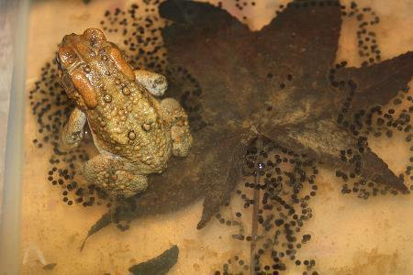

Female American Toad with strings of eggs

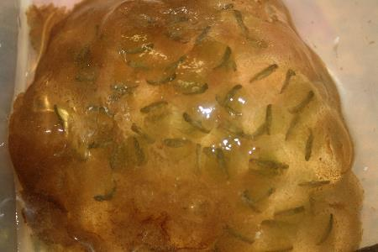

Spotted Salamander egg mass with ~1 mm larvae

**IV. Instructor Background Needed to Conduct Project**

Previous experience in biology fieldwork is very helpful but not mandatory as long as someone in the group is comfortable in the out-of-doors, especially in the water. However, it is important for the instructor to fully prepare before starting an investigation with participants. Dip netting and sampling the organisms at the study site with minnow traps should provide background information about the organisms. If there are fish, the pond may be deeper than it seems. Many amphibian-preferred wetlands are shallow and do not contain fish. Explore the pond carefully to determine the pool’s depth at its deepest point and how steep the banks are. Also check for biological hazards near the ephemeral pool, such as yellow jacket nests. Be alert to poison plants, such as poison ivy, growing in the area too, so the biotic and abiotic features particular to the study site can be pointed out to participants.

Remember, this curriculum is an inquiry investigation, so elicit as much information as possible from participants about main points rather than telling them information before they have a chance to think about what they are seeing and experiencing. Give participants a chance to think about the science behind what they see. Participants will likely raise questions or make comments about some of the main points, and if they do not mention everything, leaders can add information to the conversation after participants have had a chance to think and share. It is important to try to understand participants’ thinking in order to tactfully address any misconceptions. It is also important to note what is unknown, and to think and discuss how explanations could be investigated.

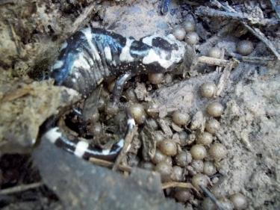

Marbled Salamander female with eggs

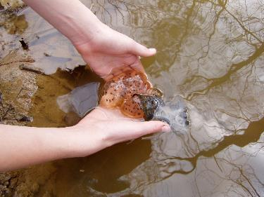

Spotted Salamander egg mass

**V. Materials**

* GPS (or use a GPS program, such as Easy GPS on your smart phone)

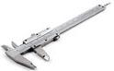

* Caliper (a device used to measure the distance between two opposite sides of an object)
* Magnifying lenses



* Thermometer
* pH strips
* Tape Measure (at least 100’ or 33 m)
* Spring or digital scales of various sizes (a spring scale is a spring fixed at one end with a hook to attach an object at the other)
* Aquatic dip nets
* Minnow traps (with one empty .5-liter soda/water/juice bottle and cap per trap to serve as a floating device for any air breathing animals that are captured)

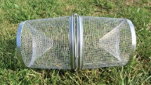

* Salamander sticks (small diameter [1/4” – 1/2”] pvc pipe, masking, duct or electrical tape, and small piece of cardboard) (Walston & Mullin, 2005)
* Rubber boots and/or chest waders depending on where participants will sample and what the area surrounding the pond is like (we have found that, for novice participants, wearing chest waders makes a huge difference in their willingness to explore the pond, enter the pond, and dip net in designated areas)
* Pictorial key to aquatic insect orders (we use printed and laminated copies of the North Carolina State Parks’ macroinvertebrate key [Appendix B])
* A field guide to the amphibians local to your area. We use *Amphibians & Reptiles of the Carolinas and Virginia,* 2010

**VI. Participant Safety in the Field**

While doing fieldwork in North Carolina, participants may encounter chiggers, yellow jackets, ticks, and spiders. Using insect repellant (but not on hands if participants plan to handle herps) and wearing a hat and long pants are useful ways of preventing these animals from biting, stinging, or attaching. Clothes can be pre-treated with insect repellant (such as Permethrin) instead of applying insect repellant to the skin. Pulling crew socks over the bottoms of pants legs is an especially good way of preventing ticks, chiggers, and spiders from crawling up legs.

Participants should also engage in safe fieldwork practices. They should wear sunscreen and carry drinking water. In hot weather, make sure participants are well hydrated; ask them to stop and drink water at regular intervals to help prevent heat stroke or other complications. Sturdy boots are useful when hiking in rough or overgrown terrain. If an area may contain snakes, know that feet and ankles are the most common bite locations, followed by hands. Wear protective footwear (such as rubber work boots to cover calves), long pants, gloves (such as leather gloves), and look before placing hands down or around a tree. Always hike with a partner and let someone else know the itinerary.

Care should be taken when working around water if students are inexperienced swimmers. Leaders should also be mindful of the dangers associated with aquatic reptiles and amphibians. Certain amphibians and invertebrates can deliver a healthy bite or pinch; first-timers not familiar with these organisms may choose to wear heavy gloves. Upon return from the field, all individuals should wash their hands immediately. In the unusual event of a serious bite or sting, medical assistance should be sought immediately even if it means termination of the activity. If participants are new to fieldwork, they may be more comfortable wearing boots, waders, and gloves to handle animals from the streams.

Instruct participants in the safe use of materials. If participants are wearing waders (waterproof overalls with boots connected), make sure to explain that they should never enter water deeper than the top of the overalls, so that the overalls do not fill with water and weigh them down and make them sink. The safe and proper use of equipment protects participants and organisms.

**VII. Animal Handling Guidelines and Animal Care**

When handling any amphibian, ALWAYS moisten hands first with ephemeral pool water to prevent the animal from drying out. Tap water from city reservoirs, often called “city water,” or other chemically treated water (including bottled water) should NEVER be used to hydrate amphibians or moisten hands. Amphibians, with their **permeable skin**, are much more sensitive to touch than scaly-skinned reptiles and must be kept wet while handling. Once captured, frogs and salamanders should be placed in a container with ephemeral pool water so that they remain in their habitat. Larvae of frogs are called tadpoles and, like salamander larvae, are especially fragile and should be handled as little as possible and with much care. Detailed handling information for various kinds of amphibians of different ages follows.

Handling Salamanders

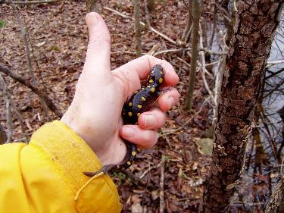

We need to be very careful when handling salamanders. Compared to the temperature of a salamander, human hands are hot. The heat from our hands and the stress of being handled can actually cause a salamander to die. There are ways to handle amphibians with a minimum of stress (for both the animals and the humans). All sizes of adult salamanders should be held with a firm but gentle grasp. Salamanders held in our palms will often jump to the ground and may injure themselves. For small salamanders, form a “cage” with hands and fingers, which will allow air to move but will not allow the animal to escape. For medium and large size salamanders (those about 5 grams and larger), grasp them firmly but gently just behind the forelimbs or in the middle of the body between the forelimbs and hind limbs.

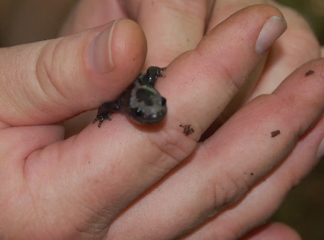

Gilled salamanders should never be grasped around the head or neck, because the gills can be easily damaged. Larvae should not be grasped with bare hands, but may be scooped up in water with bare hands for brief observation. Under most circumstances, observing these animals in this tender life-stage can be done while they remain in containers of ephemeral pool water. For close examinations, the larvae should be placed in a clear plastic bag or a shallow tray with a small amount of water that will allow them to swim freely. As much as possible, larvae should be examined only while they are in water.

Handling Frogs and Toads

When catching and handling frogs and toads, remember that their skin, like salamanders’ skin, affords little protection against **desiccation** (drying) or heat. Their thin skin absorbs oxygen from the water and the atmosphere, but the skin can also absorb anything else that it contacts. Prior to handling these animals, have all participants wash their hands. If anyone has perfume, insecticide, hand lotion, or even soap residue on their hands when they handle an amphibian, the frog or salamander will absorb it, perhaps with fatal results.

Toads are easy to handle, but do so gently. They may jump out of your hands and fall a meter or more. When toads are caught and picked up, they often urinate so expect to get peed on.

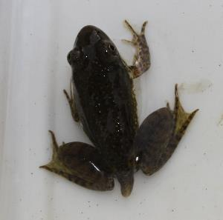

A late stage tadpole

These animals must always be handled gently. This can be a problem with frogs since they have strong muscular legs that allow them to escape a captor’s hands. A good way to hold a frog without damage is to extend the legs and hold them gently but firmly while supporting the body of the frog with the other hand. As long as the frog cannot position its legs in a raised or inclined posture, it will have a hard time jumping.

Avoid handling late stage tadpoles (large tadpoles with forelimbs already emerging and tail absorption underway). This is a critical developmental phase and amphibians are highly vulnerable at this time. Many tadpoles do not make the transformation to frogs.

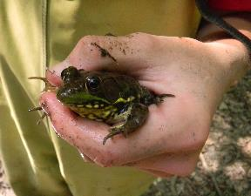 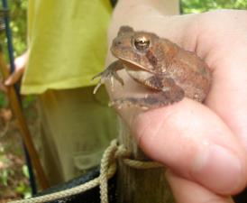

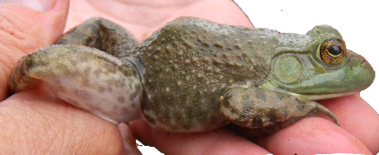

Three different but appropriate methods for handling adult frogs

Release amphibians, and all other animals, where they were caught and where they can quickly find cover. If releasing them under rocks, logs, or coverboards, lay the structure down first and then let the amphibian safely crawl under it instead of putting the cover pieces on top of the animal.

Catching Vertebrates and Macroinvertebrates

Our minnow traps (with two small open funneled ends—see photo below) are typically not baited. Organisms swim in but cannot swim out due to the shape of the trap. When setting the trap, we insert a plastic bottle filled with air and capped to make the trap float. This allows organisms to surface for air as needed while in the trap. Traps are pulled onto land and gently tapped to move all animals to one end, and opened from a latch in the middle. Traps should be checked at least once every 24 hours. Checking traps at least one every 24 hours is critically important as minnow traps are active traps and animals that are caught in these traps cannot escape. We check our traps in the morning and remove them and then reset them about dark. We often catch tadpoles, salamanders, salamander larvae, frogs, invertebrates of all kinds, and sometimes even water snakes.

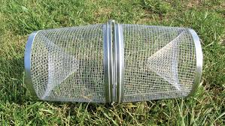

Minnow trap

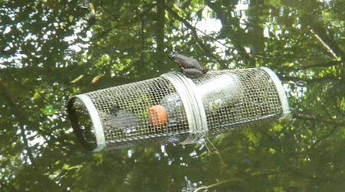

Minnow trap with floating bottle

**How to check a minnow trap video:** [**https://vimeo.com/112869602**](https://vimeo.com/112869602)

**Student checking a minnow trap video:** [**https://vimeo.com/112869803**](https://vimeo.com/112869803)

To supplement minnow traps, we also use aquatic dip nets for sampling.

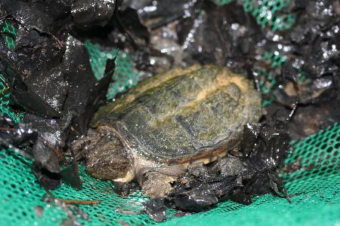

A surprise catch in an aquatic dip net—a young snapping turtle

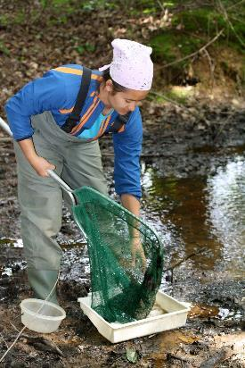

Emptying an aquatic dip net

Identifying Macroinvertebrates and Invertebrates

We start our biotic study at the pools by first identifying species. Participants decide if our animal is an invertebrate (insect, crustacean, etc.) or a vertebrate (salamander, frog, or snake). For organisms without backbones (invertebrates), we use pictorial keys (see Appendix B) and the common names of organisms that frequent ephemeral pools. Macroinvertebrates are invertebrates that can be seen with the naked eye, meaning additional magnification is not needed, although a hand lens makes them easier to see. Macroinvertebrates are identified to the family or genera level when possible.

[Fairy shrimp](http://www2.usgs.gov/blogs/csrp/2011/06/17/a-missouri-river-delicacy/) are an obligate species, common in the pools where we sample (present in late winter/early spring) and are another indicator species, only reproducing in this environment.

Other common invertebrates we may identify in Ephemeral Pools include

* Dragonfly nymphs (below, left)
* Backswimmers
* [Water boatman](http://scioly.org/wiki/index.php/Water_Quality/Macroorganism_List%20-%20Water_Boatman)
* [Water scorpions](http://scioly.org/wiki/index.php/File:Water_scorpion_ranatra_species.jpg)
* Giant water bugs (below, middle)
* [Diving beetles](http://scioly.org/wiki/index.php/Water_Quality/Macroorganism_List%20-%20Predacious_Diving_Beetle)
* Crayfish (below, right)

Identifying Vertebrates

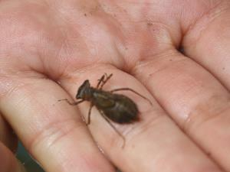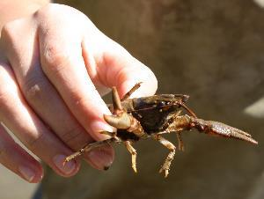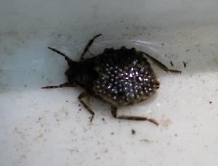

We identify vertebrates using *Amphibians & Reptiles of the Carolinas and Virginia* (2010), the field guide that we give each of our HRE participants. The field guide provides detailed information about the natural history of each species as well as range maps. In our project, salamanders and frogs are identified to species. The most common salamanders encountered in the NC piedmont are spotted salamanders, marbled salamanders, and eastern newts (also a type of salamander). Spotted salamanders are winter breeders, moving into the pools with the first warm rains of the year. Their large, conspicuous egg masses are easily identified. Marbled salamanders breed in autumn, laying their eggs in small burrows in the mud, where they wait, with their mother’s body wrapped protectively around them until the pools fill with water, to hatch. The presence of salamander adults, egg masses, or salamander larvae is used to identify an ephemeral pool. See additional photos and range maps for salamanders and frogs at www.herpsofnc.org.

The herps below are commonly found in ephemeral pools and additional information about each animal is available by going to the [Herps of North Carolina website](http://www.bio.davidson.edu/projects/herpcons/herps_of_NC/anurans/anurans.html).

* Eastern (red spotted) newts (below, top left and middle)
* Spotted salamanders (below, top right)
* Marbled salamanders (below, bottom left [male] and right [female])

|  |  |  |  |
| --- | --- | --- | --- |
|  |  | |  |
|  | |  | |

Common species of frogs in and nearby NC Piedmont Ephemeral Pools include:

* Bullfrog ([*Lithobates catesbeiana*](http://www.bio.davidson.edu/projects/herpcons/herps_of_NC/anurans/Rancat/Ran_cat.html))

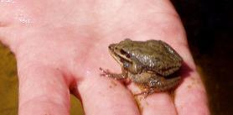

Upland chorus frog in amplexus

* Green frog ([*Lithobates clamitans*](http://www.bio.davidson.edu/projects/herpcons/herps_of_NC/anurans/Rancla/Ran_cla.html))
* Pickerel frog ([*Lithobates palustris*](http://www.bio.davidson.edu/projects/herpcons/herps_of_NC/anurans/Ranpal/Ran_pal.htm))
* Southern leopard frog ([*Lithobates sphenocephala*](http://www.bio.davidson.edu/projects/herpcons/herps_of_NC/anurans/Ransph/Ran_sph.html))
* Chorus frogs ([*Pseudacris feriarum*](http://www.bio.davidson.edu/projects/herpcons/herps_of_NC/anurans/Psefer/Pse_fer.html))
* Cricket frogs ([*Acris crepitans*](http://www.bio.davidson.edu/projects/herpcons/herps_of_NC/anurans/Acrcregry/Acr_cregry.html))
* Copes grey tree frogs ([*Hyla chrysoscelis*](http://www.bio.davidson.edu/projects/herpcons/herps_of_NC/anurans/Hylchrver/Hyl_chrver.html))
* Spring peeper ([*Pseudacris crucifer*](http://www.bio.davidson.edu/projects/herpcons/herps_of_NC/anurans/Psecru/Pse_cru.html))

**Holding and identifying a frog video:** [**https://vimeo.com/110959244**](https://vimeo.com/110959244)

Identifying Egg Masses of Salamanders and Frogs

In the fall, marbled salamanders lay many single eggs clustered together. Marbled salamanders are most likely to be seen in dry ephemeral pond beds in the fall because females stay with their eggs until the pond fills with water. In the spring, there are many eggs of both frogs and salamanders.

Toads lay their eggs in long strings while frogs lay their eggs in globular clusters. Some salamanders, like newts, lay single eggs while other salamanders, like spotteds, lay a large mass of eggs.

How to Tell a Salamander Larvae from a Tadpole

Tadpoles do not have external gills but salamanders do. Salamander gills are large and feathery-looking.

**VIII. Student Activities**

Like all of our curriculum projects, we begin the ephemeral pools project by asking students to describe the habitat as they stand near the edge of the pool. By asking a series of questions (if we need questions as prompts), we develop a nice description of the habitat where we are working. Classic ephemeral pools are shallow wetlands in the middle of deciduous forests. Branches of trees surrounding the periphery of the pool often overhang the pool. Oftentimes, pools have some aquatic vegetation. If these items are not mentioned in students’ collective descriptions of the pool, then we ask specific questions like

* Do you recognize any of the trees with branches that overhang the pool?
* Why are trees surrounding the pool important?
* What roles do submerged trees play in this pool habitat?
* What roles do floating aquatic plants play?

There are often clues to the animals that live in or use the pool. There are frogs jumping into the pool from the sides of the pool and there are animal tracks around the edges of the pools. If the **turbidity** is low, then students can often see newts and tadpoles skittering around in the pool. It is relatively easy to see a host of macroinvertebrates. In the spring, eggs of salamanders and frogs are abundant in the pool. We have minnow traps that have been set and left in the pool overnight (but less than 24 hours has elapsed between setting and checking traps) that are often moving about, full of living organisms.

We ask students if they could group all of their observations into only two categories, what categories would they choose. Typically, students offer the suggestion of living (biotic) and non-living (abiotic) factors.

From here, we first focus on abiotic factors in the pool and ask students to suggest data that we might collect about the pool habitat that would help us better understand this local environment. Once we have collected abiotic data, we collect biotic data from minnow traps.

We have included several data sheets (Appendices A-E). Based on the student activities that we are completing at the time, we use one or more of the available ephemeral pools datasheets. Some states, like Massachusetts, have an ephemeral pools certification program. We do not have such a program in NC and our ephemeral pools have limited protection. Ephemeral pools must sit on at least 20 acres of property to qualify for special tax credits in NC. We modified the [Massachusetts certification guidelines](http://www.mass.gov/eea/docs/dfg/nhesp/vernal-pools/vpcert.pdf) for use in NC (Appendices A, B, and C). The other two forms are similar. Both forms are used to record data gathered in ephemeral pools from minnow traps. Appendix E is a form that we use for 25 traps in a pool, while the shorter form, with lines for one or two traps, are assigned to individuals (Appendix D).

Abiotic Data Collection Activities

We begin our abiotic data collection activities by asking students what data they think that we should collect and why these data might be useful to our study of ephemeral pools. We begin with asking, “Where are we?” We make sure that students know our county and ask them the best way to ensure that others could locate this pool to duplicate our findings. Usually someone suggests we get a GPS location. Then, we ask students what kinds of abiotic data they think we should collect. We usually get variables such as air and water temperature. We often have to suggest some variables too, such as circumference and depth of the ephemeral pool. We have students collect these data and, when we have time, we often try multiple ways of collecting the data (different kinds of thermometers for temperature, repeated measures of circumference of the pool, etc.).

Typically, we collect the following abiotic data: exact location (GPS coordinates), pH, water temperature, air temperature, relative humidity, wind speed and direction, % cloud coverage, rainfall amount and days since last rainfall, circumference of vernal pool, and water depth at the deepest spot in the pool.

**How to measure circumference of ephemeral pool video:**[**https://vimeo.com/112706844**](https://vimeo.com/112706844)

Collecting abiotic data generates a lot of data. But we also need careful records of all living organisms. Typically, we collect abiotic data first and then check minnow traps. The following section describes the biotic data we collect to use during our future studies.

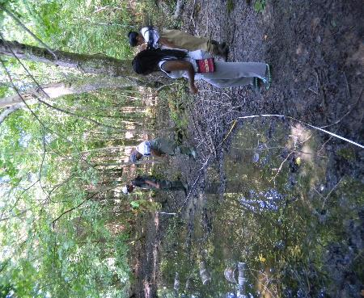 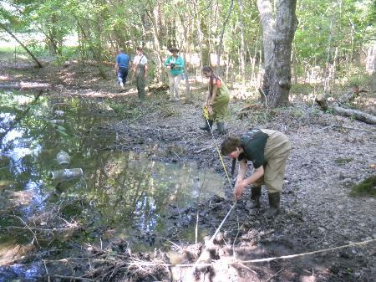

HRE participants measuring the circumference of an ephemeral pool

Biotic Data Collection Activities

Once we have collected abiotic data, we briefly discuss our findings and speculate how these variables affect life in the pool. Then, we begin to empty minnow traps, with students recording their finds on hard copy data sheets (see Appendices A-E) or our Herp Project app (Aquatic Habitat Data). We demonstrate how to carefully open the minnow traps and empty the contents into a water-filled container. Then, the inquiry really begins: “What is this?” “What is it doing?” “What’s happening (or has happened here)?” Each pair of students has their own trap(s) to empty and their own biotic data to record. Often, we ask the students to share their finds with others or we bring the group together to see what different pairs of students found. Student findings drive our field sessions. We encounter everything from frogs in all stages of metamorphosis, to salamander and frog larvae and eggs, macroinvertebrates that our participants have never seen, animals that our students have never heard (often, frogs are calling during our investigations), and events that our students (and sometimes us) have never witnessed, like a newt shedding and eating its skin or a frog skeleton completed cleaned, left in the minnow trap (what did this?). Students have their field guides and simple dichotomous keys (Appendix F) to help identify adult salamanders, frogs, and the very occasional snake or turtle. We always use the guide’s description, photographs, and range maps to identify animals using the “**Rule of Three**.”

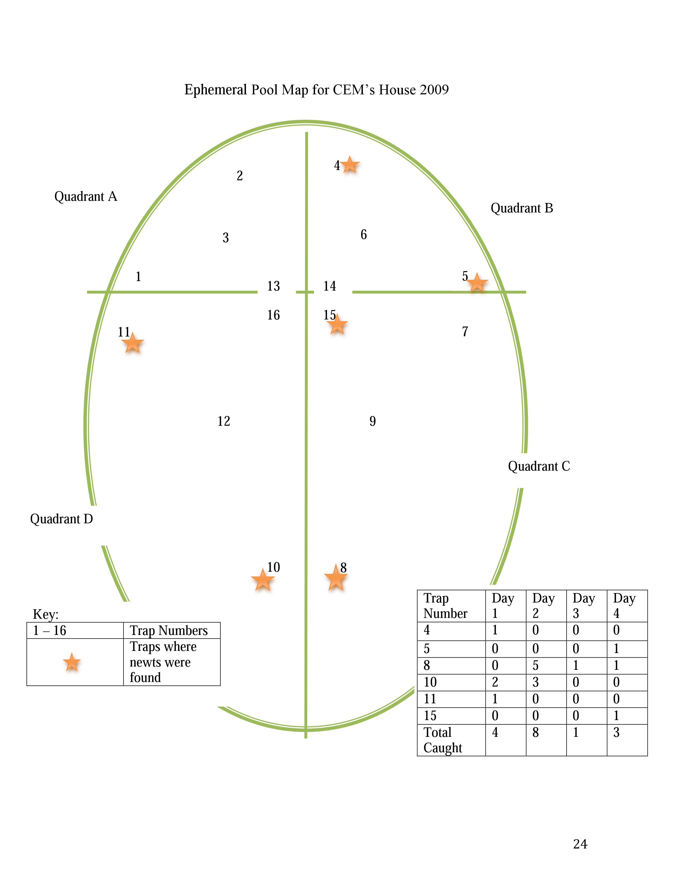Below is a sketch of an ephemeral pool we monitor. Note trap locations and data table.

Each trap should be emptied carefully and its contents recorded. The interval between setting traps and checking active traps, such as minnow traps from which animals cannot escape, should be as short as possible, and never more than 24 hours. A set trap is a potential death sentence for the trapped animal and it is the researcher’s ethical imperative to check traps in a timely manner. Lead instructors/investigators must make every effort to prevent trap deaths from exposure or drowning. Minnow traps can be placed in very shallow water as long as one opening is submerged. However, be sure to anchor the minnow trap so that it does not float to another, deeper location. The traps should be positioned using some type of flotation device (we use 12-ounce empty water, soda and juice bottles with caps) so that captured amphibians without gills have access to air. We make sure that each of our traps floats before we leave our study site.

Our data includes identifications of various species of reptiles, amphibians, and macroinvertebrates, distinguishing between males and females when possible, estimating ages, measuring and weighing animals, and using species-specific techniques to mark animals. Vertebrates are identified to life stage—tadpole or larva with/without legs, tails, gills as appropriate. Remember—larval forms are very delicate. The only data we collect on amphibian larvae are gills or no gills (salamanders) and how many and which legs are present and whether or not a tail (frogs) is still present. We do not take any measurements of amphibian larvae. Participants are typically fascinated by the real life lessons on metamorphosis. Data we collect on adult salamanders and frogs and toads include sex, life stage/age, length, and weight. Data sheets for this project are included in Appendices A-E.

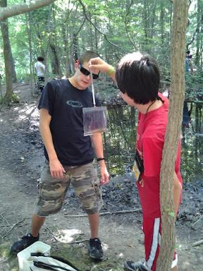

Two HRE participants mass a newt

|  |  |  |  |  |  |
| --- | --- | --- | --- | --- | --- |
| **Data** | **Sex**  **(F or M)** | **Life stage/age** | **Total Length (mm)**  **Adult Salamanders Only** | **Snout to Vent Length (SVL) (mm)**  **Adults only** | **Mass**  **(g)**  **Adults only** |
| Tips | Male or Female?  **Dimorphic Coloration**    Examples:  1.) Male eastern newts have black **Velcro-**like pads or circles on the ends of their toes and the inside of their back legs  2.) Marbled salamander males are more **brightly colored** than females  3.) Male frogs have **dark colored throats** (which are deflated vocal sacs); only male frogs call (females do not have vocal sacs and do not call) | Adult or Larva?  For Salamander larvae – **Are gills present**?  **How many and which legs** are present (no legs, two front legs, or all four legs)?  For tadpoles – How many and which legs are present (no legs, two front legs, or all four legs)?  **Is there a tail**? | What is the **length**?  Use **calipers** to measure.  Measure from the tip of the snout to the end of the tail. | What is **SVL**?  The vent is the opening between the two hind legs that is used for excretion and reproduction.  Use calipers to measure.  Measure from the **tip of the snout** to the **posterior end** of the vent. | What is the **mass**?  Place the organism in a plastic bag with a small amount of ephemeral pool water.  Use a **spring scale** to weigh the organism and the bag.  Once recorded, remove the organism from the bag gently and reweigh the bag by itself.  Subtract the mass of the bag from the mass with the organism to get the mass of the organism. |
| These two lengths are important as salamanders can lose and regenerate their tails.  Find the ratio of the two lengths by dividing the SVL by the total length. | |

A picture of a male eastern newt can be seen at [http://www.wildlife.state.nh.us/Wildlife/ Nongame/salamanders/east-redspot_newt.htm](http://www.wildlife.state.nh.us/Wildlife/%20Nongame/salamanders/east-redspot_newt.htm).

Following the collection of abiotic data and then data on organisms caught in minnow traps, we sample the pond with aquatic dip nets. Dip netting can stir up sediment and make the water murky. The suspended sediments can make it more difficult for gill breathers to take in the air they need. Therefore, we are cautious about the about of net dipping that we allow.

**How to mass a salamander video:** [**https://vimeo.com/112870042**](https://vimeo.com/112870042)

Additional Research Possibilities

We use Frog Loggers to record frog calls at the ephemeral pools that we study. Frogloggers are digital recording devices (data is stored on SD cards) that can be programmed to record sounds at specific times of the day and with a specific regularity. HRE participants and teachers then listen to these recorded frog calls and ask such questions as:

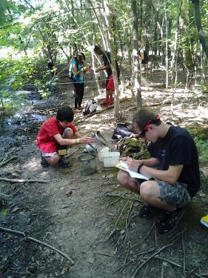

Participants collecting and recording data at an ephemeral pool.

1. What frogs are calling at the ephemeral pool?
2. Are these the same frogs that are calling at a different ephemeral pool?
3. If the same (or different) calls are heard, why do you think this is so?
4. Are there seasonal patterns in frog calls?
5. Are there daily patterns in frog calls?
6. What happens to pitch and intensity of frog calls when a truck drives by or an airplane flies over the pool?

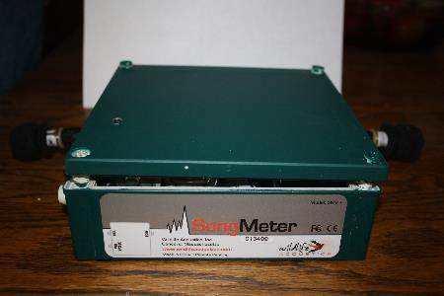

Side view of frog logger (song meter)

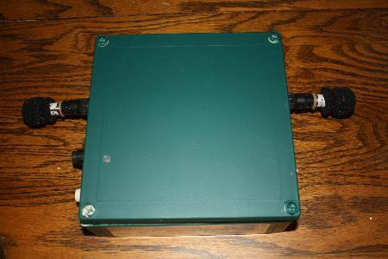

Frog logger with two microphones

If you want to learn North Carolina frog calls, you can easily do so at the [Herps of North Carolina website](http://www.bio.davidson.edu/projects/herpcons/herps_of_NC/anurans/anurans.html), a Davidson College website on reptiles and amphibians of North Carolina. Information and range maps are provided about each species of frog in the state and frog calls can be heard by clicking a play button. Other states may have similar frog call databases.

Fluorescent tracking powder can be used to analyze the terrestrial movements of salamanders at night. Simply dip the salamanders’ feet in the powder and release it at the point of capture, being careful not to get any of the powder in the salamanders’ mouth or eyes. Return in the evening with a blacklight to follow its path. Identifying where the salamander was first spotted and measuring how far the salamander traveled can provide further data for analysis.

Participants can also make observations of salamander behavior in a science notebook; this enhances students’ observation skills. Switching to baited traps is another possibility. After periods of using unbaited traps, we request questions from our participants to drive our future studies. Participants may ask, “Do baited traps (with assumed preferred foods) work better than unbaited traps? If so, what types of bait work best?” or “What is the effect of camouflage on trapping efficiency?” Participants could also experiment with coverboards, which adult frogs and salamanders use. Do they prefer tin or wood? Or do they prefer tree cookies cut from one species of tree versus another?

Data Reporting to The HERP Project and HerpMapper

Our data are uploaded to The HERP Project’s database ([theherpproject.uncg.edu](https://theherpproject.uncg.edu/)). Data can also be uploaded to share with the public and scientists worldwide on the HerpMapper citizen science site (www.herpmapper.org).

**IX. Resources**

**Web Resources**

Climate Change and Ephemeral Pool Ecosystems: Potholes and vernal pools as potential indicator systems. <http://geochange.er.usgs.gov/sw/impacts/biology/vernal/>

Checklist of the amphibians and reptiles of North Carolina. Beane, J. C., and A. L. Braswell, 2011.<http://naturalsciences.org/research-collections/research-specialties/amphibiansreptiles>

Winter and Early Spring Vernal Pool Egg Mass Identification: Pt. 1 Frogs <http://midatlanticnature.blogspot.com/2012/01/winter-and-early-spring-vernal-pool-egg.html>

Winter and Early Spring Vernal Pool Egg Mass Identification: Pt. 2 Salamanders <http://midatlanticnature.blogspot.com/2012/02/winter-and-early-spring-vernal-pool-egg.html>

**Books and articles**

Beane, J., Braswell, A., Mitchell, J., Palmer, W. & Harrison III, J. (2010). *Amphibians & Reptiles of the Carolinas and Virginia*. (2d Ed. Revised). Chapel Hill, NC: UNC Press.

Best, M. & Welsh, Jr., H. (2014). The trophic role of a forest salamander: impacts on invertebrates, leaf litter retention, and the humification process. *Ecosphere (5)* 2 Article 16*.* Retrieved from [http://www.esajournals.org/action/showCitFormats?doi=10.18 90%2FES13-00302.1](http://www.esajournals.org/action/showCitFormats?doi=10.18%2090%2FES13-00302.1)

Calhoun, A. J. K. & deMaynadier, P. G. (2008). *Science and Conservation of Vernal Pools in*

*Northeastern North America*. Boca Raton, FL: Taylor & Francis.

International Society for Technology in Education (ISTE). (2007) Student Standards  
<https://www.iste.org/docs/pdfs/20-14_ISTE_Standards-S_PDF.pdf>

NGSS Lead States. 2013. *Next Generation Science Standards: For States, By State*s. Washington, DC: The National Academies Press.

Walston. L. & Mullin, S. (2005). Evaluation of a New Method for Measuring Salamanders. *Herpetological Review 36* (3), 290 – 292.

**Visual learning software**

VL HERPSis a free visual learning software program designed for learning reptiles and amphibians of the Southeast at home. [http://theherpproject.uncg.edu/ visual-learning-software/](http://theherpproject.uncg.edu/%20visual-learning-software/)

Especially for Landowners

If a landowner has an ephemeral pool on their property, a landowner packet can be used to notify them of the special habitat on their property and offers suggestions for how they can help maintain it. The packet raises awareness about the habitat and the species that use this habitat. Nearly all of our ephemeral pools are on private land and therefore landowner support is critical. A landowner packet is located on the [Herp Project website](https://theherpproject.uncg.edu/).

**X. Especially for Teachers**



**Appendix A. Data Sheet**

**Ephemeral Pool Observation Form**

**Mapping**

Site ________________________________________

County/ State _________________________________________________________

Observation Date ____________________________________________________

Survey Members _______________________________________________________________

______________________________________________________________________________

GPS Location: _______________________________

Written directions to pool: ________________________________________________________

______________________________________________________________________________________________________________________________________________________________________________________________________________________________________________________________________________________________________________________________________________________________________________________________________

Written description of pool (be as descriptive as possible, referencing permanent features):

__________________________________________________________________________________________________________________________________________________________________________________________________________________________________________________________________________________________________________________________________________________________________________________________________________________________________________________________________________________________________________________________________________________________________

Attach a google map that clearly shows the location of the ephemeral pool. Also attach multiple photographs of the vernal pool. Your photographs should establish that the pool is isolated from other bodies of water. On the back of each photograph label the location, date, direction being viewed and sign them. You should also take a picture of the vernal pool dry to show that there are not fish present.

The Herp Project is supported by the National Science Foundation, Grant No. DRL-1114558. Any opinions, findings, and conclusions or recommendations expressed in this manuscript are those of the authors and do not necessarily reflect the views of the National Science Foundation.

**Appendix B. Data Sheet**

**Ephemeral Pool Observation Form:**

**Evidence of Obligate and Facultative Species**

Site _________________________________County/ State _____________________________

Observation Date __________________________Survey Members _______________________

______________________________________________________________________________

**Indicate the number of obligate organisms:**

|  |  |  |  |  |  |
| --- | --- | --- | --- | --- | --- |
|  | Courting adults | Spermatophores | Egg Masses | Salamander Larvae | Transforming Juveniles |
| Spotted Salamander |  |  |  |  |  |
| Marbled Salamander |  |  |  |  |  |
| Fairly Shrimp |  |  |  |  |  |
| Other |  |  |  |  |  |

**Indicate the number of facultative species:**

|  |  |  |
| --- | --- | --- |
|  | Number observed | Activity observed |
| Breeding Spring Peepers |  |  |
| Breeding Gray Treefrogs |  |  |
| Breeding Green Frogs |  |  |
| Breeding Leopard Frogs |  |  |
| Breeding Pickeral Frogs |  |  |
| Breeding American Toads |  |  |
| Breeding Fowler’s Toads |  |  |
| Eastern Newts |  |  |
| Turtles (give name) |  |  |
| Predaceous diving beetle larvae |  |  |
| Water scorpions |  |  |
| Dragonfly nymphs |  |  |
| Damselfly nymphs |  |  |
| Dobsonfly larvae |  |  |
| Whirligig beetle larvae |  |  |
| Caddisfly larvae |  |  |
| Leeches |  |  |
| Freshwater Clams |  |  |
| Air-Breathing Snails |  |  |
| Other |  |  |

Make sure to document each organism with a photograph. You should label each photograph with subject, date, and location.

**Appendix C. Data Sheet**

The Herp Project is supported by the National Science Foundation, Grant No. DRL-1114558. Any opinions, findings, and conclusions or recommendations expressed in this manuscript are those of the authors and do not necessarily reflect the views of the National Science Foundation.

**Ephemeral Pool Observation Form:**

**Wetland Plants**

Site ________________________________________

County/ State _________________________________________________________

Observation Date __________________________Survey Members _______________________

______________________________________________________________________________**Indicate Wetland species present**. Be sure to document each with a photograph. You should label each photograph with subject, date, and location.

|  |  |  |
| --- | --- | --- |
|  | Absent | Present |
| Duckweeds (*Lemna* spp., *Spirodela* spp., *Wolffia* spp.) |  |  |
| Fountain moss (Fontinalis spp.) |  |  |
| False mermaid weeds (*Proserpinaca palustris* and *P. pectinata*) |  |  |
| Bur-reeds (*Sparganium androcladum* and *S. chlorocarpum*) |  |  |
| Buttonbush (*Cephalanthus occidentalis*) |  |  |
| Pondweeds (*Potamogeton* spp.) |  |  |
| Bladderworts (*Utricularia clandestina*, *U. gibba* and *U. subulata*) |  |  |
| Water-milfoils (*Myriophyllum humile* and *M. tenellum*) |  |  |
| Water plantain (*Alisma plantago-aquatica*) |  |  |
| Yellow water-crowfoot (*Ranunculus flabellaris*) |  |  |
| Featherfoil (*Hottonia inflata*) |  |  |
| Water-starworts (*Callitriche* spp.) |  |  |
| False pimpernels (*Lindernia anagallidea* and *L. dubia*) |  |  |
| Lance-leaved violet (*Viola lanceolata*) |  |  |
| St. John's-worts (*Hypericum adpressum*, *H. boreale*, *H. canadense*, and *H. mutilum*) |  |  |
| Smartweeds (*Polygonum amphibium*, *P. hydropiper*, *P. hydropiperoides*, *P. pensylvanicum* and *P. punctatum*) |  |  |
| A rush (*Juncus pelocarpus*) |  |  |
| Sedges (*Rhynchospora capitellata* and *R. fusca*) |  |  |
| Grasses ( *Agrostis scabra, Glyceria acutiflora, G. canadensis, G. fernaldii, G. pallida, Muhlenbergia uniflora, Panicum dichotomiflorum, P. meridionale, P. philadelphicum, P. rigidulum, P. tuckermanii, P. verrucosum*) |  |  |
| Other |  |  |

Sketch the ephemeral pool area and identify the site of each plant species listed above.

The Herp Project is supported by the National Science Foundation, Grant No. DRL-1114558. Any opinions, findings, and conclusions or recommendations expressed in this manuscript are those of the authors and do not necessarily reflect the views of the National Science Foundation.



**Appendix D. Data Sheet**

**Ephemeral Pool Population Survey (for individual traps)**

|  |  |  |  |  |  |  |  |  |  |  |
| --- | --- | --- | --- | --- | --- | --- | --- | --- | --- | --- |
| **Trap #** | **Spotted Salamander Larvae** | | | | **Eastern Newt** | | | | **Other amphibians** | **Macroinvertebrates** |
|  | Indicate individual # then Total # | Total Length (cm) | # legs | External gills absent or present | Indicate individual # then Total # | Total length (cm) | Mass (g) | gender | Name/total # | Name/total # |
| Sample  Trap 1 | 1  2  Total 2 | 5  3 | 4  2 | Present  present | 1  2  3  Total 3 | 9  10  8.5 | 2.8  4  3.5 | M  M  F | Bullfrog-2  Unidentified tadpoles-4 | Fairy shrimp-3  Dragonfly nymph-2  Water scorpion-1 |
|  |  |  |  |  |  |  |  |  |  |  |
|  | | | | | | | | | | |

|  |  |  |  |  |  |  |  |  |  |  |
| --- | --- | --- | --- | --- | --- | --- | --- | --- | --- | --- |
| **Trap #** | **Spotted Salamander Larvae** | | | | **Eastern Newt** | | | | **Other amphibians** | **Macroinvertebrates** |
|  | Indicate individual # then Total # | Total Length (cm) | # legs | External gills absent or present | Indicate individual # then Total # | Total length (cm) | Mass (g) | gender | Name/total # | Name/total # |
| Sample  Trap 1 | 1  2  Total 2 | 5  3 | 4  2 | Present  present | 1  2  3  Total 3 | 9  10  8.5 | 2.8  4  3.5 | M  M  F | Bullfrog-2  Unidentified tadpoles-4 | Fairy shrimp-3  Dragonfly nymph-2  Water scorpion-1 |
|  |  |  |  |  |  |  |  |  |  |  |

The Herp Project is supported by the National Science Foundation, Grant No. DRL-1114558. Any opinions, findings, and conclusions or recommendations expressed in this manuscript are those of the authors and do not necessarily reflect the views of the National Science Foundation.



**Appendix E. Data Sheet**

**Ephemeral Pool Population Survey**

Field Notes:   
Day/ Date ______________ Collection Time __________ Air Temperature _________ °C Water Temperature ___________°C

Circumference of the Ephemeral Pool at water level ___________________ meters

|  |  |  |  |  |  |  |  |  |  |  |
| --- | --- | --- | --- | --- | --- | --- | --- | --- | --- | --- |
| **Trap #** | **Spotted Salamander Larvae** | | | | **Eastern Newt** | | | | **Other Amphibians** | **Macroinvertebrates** |
|  | Indicate individual # then Total # | Total Length (mm) | # legs | External gills absent or present | Indicate individual # then Total # | Total length (mm) | Mass (g) | gender | Name/total # | Name/total # |
| Sample Trap 1 | 1  2  Total 2 | 10  8 | 2  2 | Present  present | 1  2  3  Total 3 | 19  30  26 | 2.8  4  3.5 | M  M  F | Bullfrog-2  Unidentified tadpoles-4 | Fairy shrimp-3  Dragonfly nymph-2  Water scorpion-1 |
| 1 |  |  |  |  |  |  |  |  |  |  |
| 2 |  |  |  |  |  |  |  |  |  |  |
| 3 |  |  |  |  |  |  |  |  |  |  |
| 4 |  |  |  |  |  |  |  |  |  |  |
| 5 |  |  |  |  |  |  |  |  |  |  |

|  |  |  |  |  |  |  |  |  |  |  |
| --- | --- | --- | --- | --- | --- | --- | --- | --- | --- | --- |
| 6 |  |  |  |  |  |  |  |  |  |  |
| 7 |  |  |  |  |  |  |  |  |  |  |
| 8 |  |  |  |  |  |  |  |  |  |  |
| 9 |  |  |  |  |  |  |  |  |  |  |
| 10 |  |  |  |  |  |  |  |  |  |  |
| 11 |  |  |  |  |  |  |  |  |  |  |
| 12 |  |  |  |  |  |  |  |  |  |  |
| 13 |  |  |  |  |  |  |  |  |  |  |

|  |  |  |  |  |  |  |  |  |  |  |
| --- | --- | --- | --- | --- | --- | --- | --- | --- | --- | --- |
| 14 |  |  |  |  |  |  |  |  |  |  |
| 15 |  |  |  |  |  |  |  |  |  |  |
| 16 |  |  |  |  |  |  |  |  |  |  |
| 17 |  |  |  |  |  |  |  |  |  |  |
| 18 |  |  |  |  |  |  |  |  |  |  |
| 19 |  |  |  |  |  |  |  |  |  |  |
| 20 |  |  |  |  |  |  |  |  |  |  |
| 21 |  |  |  |  |  |  |  |  |  |  |

|  |  |  |  |  |  |  |  |  |  |  |
| --- | --- | --- | --- | --- | --- | --- | --- | --- | --- | --- |
| 22 |  |  |  |  |  |  |  |  |  |  |
| 23 |  |  |  |  |  |  |  |  |  |  |
| 24 |  |  |  |  |  |  |  |  |  |  |
| 25 |  |  |  |  |  |  |  |  |  |  |

Additional Information related to this day of data collection:

The Herp Project is supported by the National Science Foundation, Grant No. DRL-1114558. Any opinions, findings, and conclusions or recommendations expressed in this manuscript are those of the authors and do not necessarily reflect the views of the National Science Foundation.

**Appendix F. Macroinvertebrate Key**

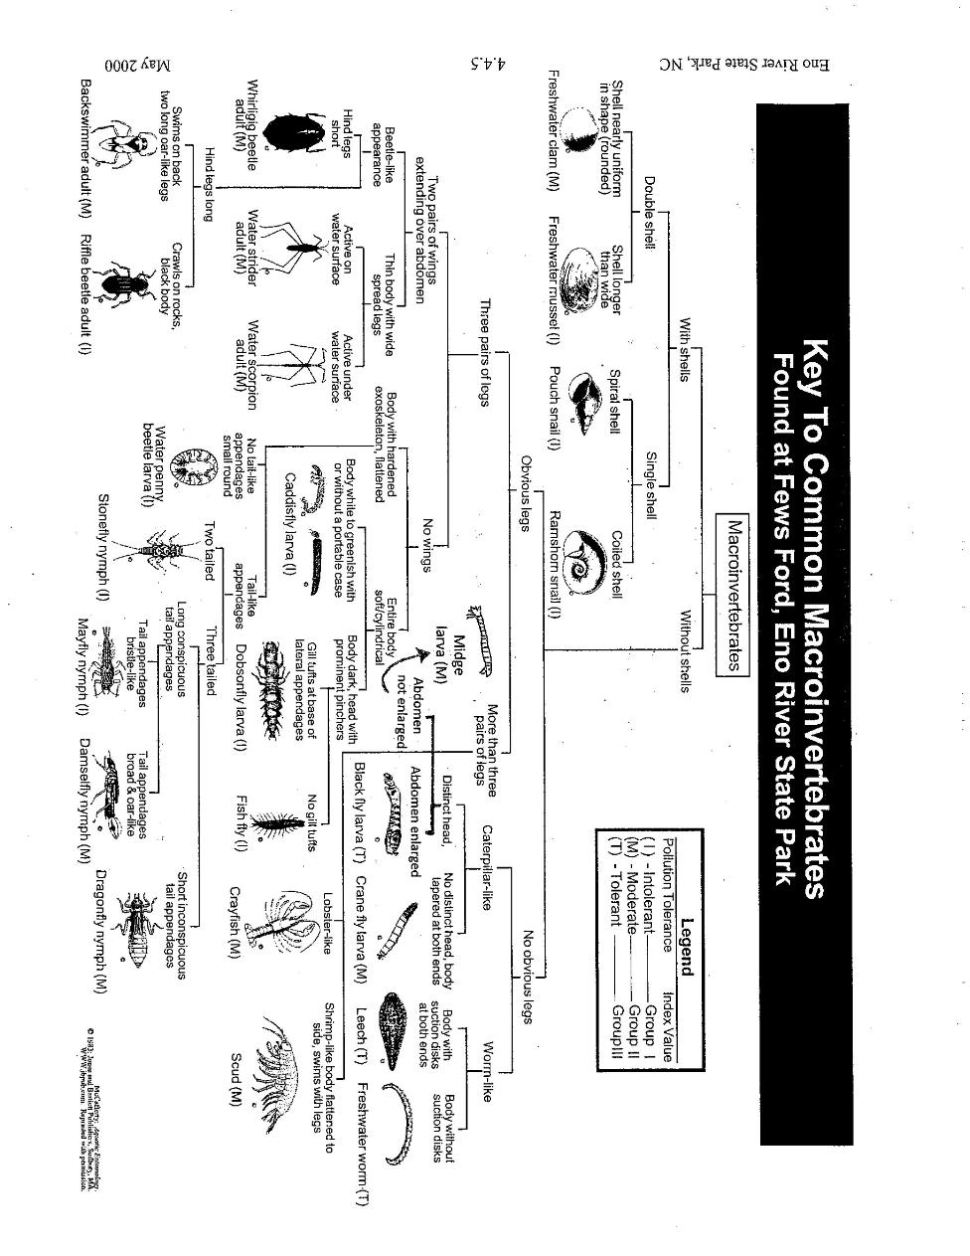

**Appendix G. Glossary**

**abiotic factors**: nonliving habitat variables including for example temperature, moisture, topography, soil type, percent cloud cover, and days since last rainfall

**biomass**: the weight of living organisms in a specific area of land

**biotic data**: information about living organisms including for example length, weight (mass), sex, eye color, claw length and position of the vent

**calipers**: tools to measure distances such as height of shell or length of body

**capture efficiency**: called capture per unit effort (CPUE), which is an indirect measure of the abundance of the species of interest

**desiccation**: drying

**dimorphic coloration**: animal species with color patterns that vary by sex (for example, male marbled salamanders are much brighter than females; male and female box turtles have eyes of different colors – usually reddish for males and yellowish for females)

**ephemeral pools**: temporary puddles or seasonal wetlands or vernal pools

**facultative**: organisms that are not ‘obligated’ to or limited to the use of ephemeral pools but use them anyway for convenience

**habitat fragmentation**: the splitting of areas of land so that land areas are pockmarked by roads, railways, powerlines, etc.

**macroinvertebrates**: small animals without backbones that can be seen with the naked eye like dragonfly nymphs and diving beetles and caddis fly larvae

**obligate**: organisms that must use ephemeral pools for breeding

**permeable skin**: a surface that allows materials, like liquids and gases, to pass through—either in or out

**Snout to Vent Length** (SVL): the length of an animal from the tip of the snout to the posterior end of the vent

**turbidity**: particles that reduce the clarity of a body of water